

Measurement of muon lifetime

John Gresl  
Jessica Siqueiros  
Jaycob Jalomo  
*Department of Physics and Astronomy, University of California Irvine, California 92612, USA*  
Submitted: May 7 2017

**1.** **Abstract**

A measurement of the muon’s lifetime is performed using polystyrene scintillators and electronic counting circuits. Data was taken over the course of 595201 seconds, or 6.89 days and then separated into 36 equally spaced bins. The dataset, consisting of 1,650 muons, was then fit using Mathematica’s NonlinearModelFit function which reported a characteristic muon lifetime of .

**2. Introduction**

Muons were discovered in 1937 by C.W. Anderson and S.H. Neddermeyer when they examined the paths created by cosmic rays passing through a cloud chamber1. The muon source for our experiment are these cosmic rays. In the upper atmosphere, highly energetic protons (cosmic rays) interact with atmospheric gasses and produces showers of subatomic particles which in turn produce secondary showers of more subatomic particles, like muons.

Muons are elementary particles and are a member of the lepton group within the standard model. The charge of the muon is identical to that of the electron and its mass is about 207 times the mass of the electron. With many other identical characteristics to the electron such as spin, weak isospin, and weak hypercharge, the muon is sometimes referred to as a heavy electron.

**3. Muon Physics**

Muons only interact with matter via electromagnetic interactions and weak interactions with the latter being the cause of their decays. Using Feynman rules, we can calculate the theoretical lifetime, , of the muon to be

where is the Fermi coupling constant, is the mass of the muon, and is the mass of the electron2. The accepted value for the muon’s lifetime3 is 2.196981 0.000022 . The muons large mass makes it unstable and causes it to decay via the weak interaction almost exclusively into an electron and two neutrinos (see figure 1). The muon’s lifetime can be determined experimentally by fitting the decay rate to an exponentially decaying Poisson process  
where is the number of muons at time and is a normalization parameter.



Figure 1. Feynman diagram of a muon decaying into a mu neutrino, an electron, and an anti-electron neutrino. Muon and electron number is conserved in this diagram.

**4. The Experiment**

To detect these cosmic rays, we have three rectangular plastic slab scintillators oriented on top of each other and shielded from outside light. Each scintillator has a cross sectional area of 0.74 square meters and is then attached to a photo multiplier tube (PMT) and an in-line amplifier. From top to bottom, the scintillators will be referred to as , , and and the associated voltages will be referred to as , , and , respectively.

Once the PMT signals are amplified, they are each fed into a unique discriminator which converts an otherwise non-uniform pulse into a logical square wave. The discriminators are triggered when the input signal from the amplifier is above a certain threshold. 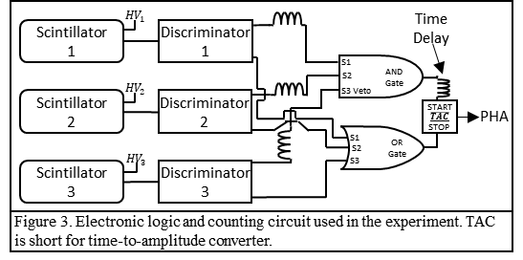In our experiment, we set each discriminator threshold to 150 mV. This value was determined by finding a voltage that was high enough filter out random noise, but low enough to allow any true event to trigger the discriminator (see figure 2).

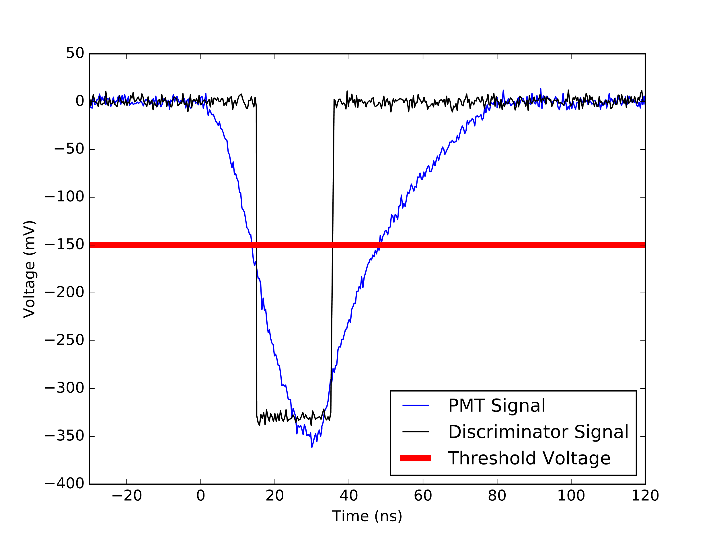

Figure 2. Oscilloscope data of a muon decay in the PMT (blue), the discriminator’s response (black), and the discriminators threshold, or trigger voltage (red). Signals have been smoothed roughly.

The square waves are then sent to discreet logic units which compute the logical portion of our circuit. Since our scintillators are arranged top to bottom, we are interested in events where a muon enters through the top scintillator and stops in the middle scintillator. We are not interested in events where a muon traverses through all three scintillators since this means the muon was not captured. We can detect the decay of the muon by detecting an electron in any of the three scintillators. The logic for a muon capture is and the logic for muon decay is   
. To ensure the capture signal is appropriately vetoed when a signal in the bottom scintillator is detected, we set the widths of the discriminators so that the third discriminator completely envelopes the first two. We have set the widths of the first two discriminators to 30 ns and the width of the third to 70 ns.

The logical circuits are then connected to a time-to-amplitude converted (TAC) with the muon capture signal starting the timer and the muon decay signal stopping it. Any time the capture logic is true, the decay logic will *also* be true. For this reason, we add a slight delay of 48 ns to the capture signal before it is connected to the TAC. The TAC is then connected to a pulse height analyzer (PHA) program on a computer. The PHA will display a histogram of decay times which can then be used for analysis. The entire circuit can be found in figure 3.

**5. Results**

The histogram from the PHA was sorted into 36 equally spaced bins of 0.125 each and then fit to the exponential decay model mentioned earlier using Mathematica’s NonlinearModelFit function. With 16,500 muon decay events gathered over 595201 seconds (~7 days), we calculated a characteristic lifetime (see figure 4). NonlinearModelFit also provides an adjusted which gauges the quality of fit. Our model yielded an adjusted of . The error of is calculated by taking the square root of the diagonal element of the covariance matrix corresponding to .

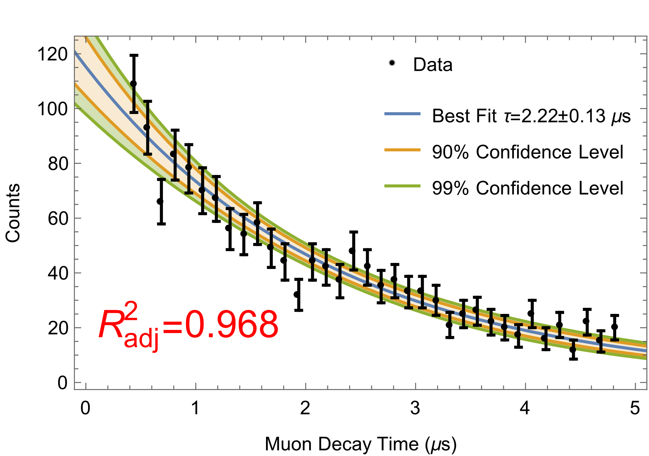

Figure 4. Histogram of decay times from our PHA with error bars (black) and best fit as determined by Mathematica’s NonlinearModelFit (blue). The confidence bands indicate how confident we are that the actual result lies within the band. i.e. we are 90% confident that the actual muon lifetime model lies within the orange band and 99% confident that it lies within the green band. (color online).

**6. Bibliography**

1. Neddermeyer, S. H. & Anderson, C. D. Note on the Nature of Cosmic-Ray Particles. *Phys. Rev.* **51,** 884–886 (1937).

2. Yao, W.-M. Review of Particle Physics. *J. Phys. G Nucl. Part. Phys.* **33,** 1 (2006).

3. Olive, K. A. & Olive, K.A, et al., (Particle Data Group). Review of Particle Physics. *Chinese Phys. C* **38,** 90001 (2014).

**7. Appendix**

**I. Calibration of Photo Multiplier Tube Voltages**

Every PMT is slightly different and must have its input voltage calibrated individually. For this reason, we record the count rate of each PMT while varying the voltage. Ideally, we would expect a steady increase in count rate until we reach a plateau of maximum counting efficiency. Above this plateau will be an exponential increase in count rate as the signal becomes increasingly saturated. This plateau is found by plotting vs and then locating the plateau using a modified divided difference algorithm.

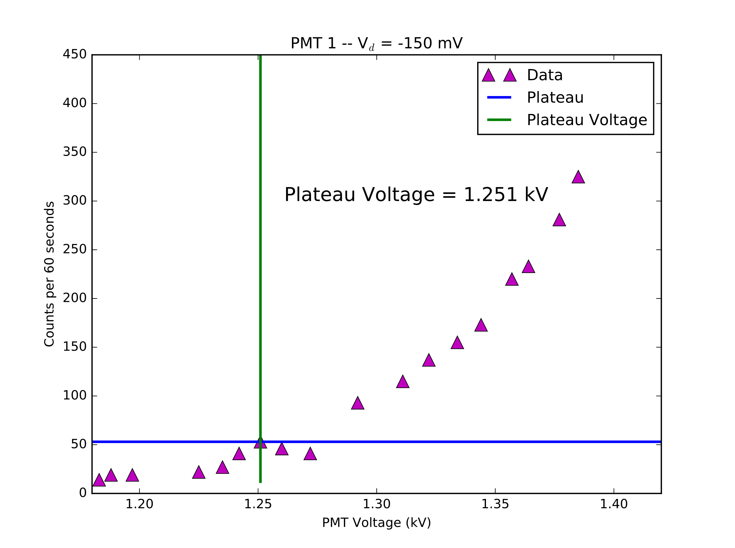

Figure 5. Determination of plateau voltage for the top-most PMT. A voltage of 1.251 kV was selected because it yielded the maximum number of counts and was almost immediately before the sharp increase.

**Tip to future experimenters**: The actual volt meter on the high voltage supply is broken (at the time of writing this report). To get an accurate reading of the PMT voltage without having to guess based on a dial’s location, one may use a standard 2-lead voltmeter set on the *2 Volt Max DC* setting. Insert one of the leads from the voltmeter into small opening next to the “1000:1 5% -- Use DVM” sticker corresponding to the PMT you are trying to measure. Touch the other lead from the voltmeter to the inner wall of the exterior casing of the same opening. If you have done this correctly and your high voltage is on, you should see a value between 0 and 2 on your voltmeter. Multiply this number by 1,000 to obtain your actual PMT voltage (within a 5% margin of error). CAUTION: Do not insert anything into the “HV IN” or “HV OUT” openings!

**II. Calibration of Discriminator Signal Delays**

Muons usually travel at non-relativistic speeds, meaning that their travel time from scintillator to scintillator cannot be ignored. For this reason, we adjust the time delay between scintillator signals until we observe a maximum count rate. We find that there is a maximum when the cable for is the shortest and is the longest (see figure 6).

Figure 6. Plot of delay calibration between the first and third discriminator. A value of 8 on the x-axis  
indicates that S3 takes 8 ns longer than S­­1 to reach the TAC.

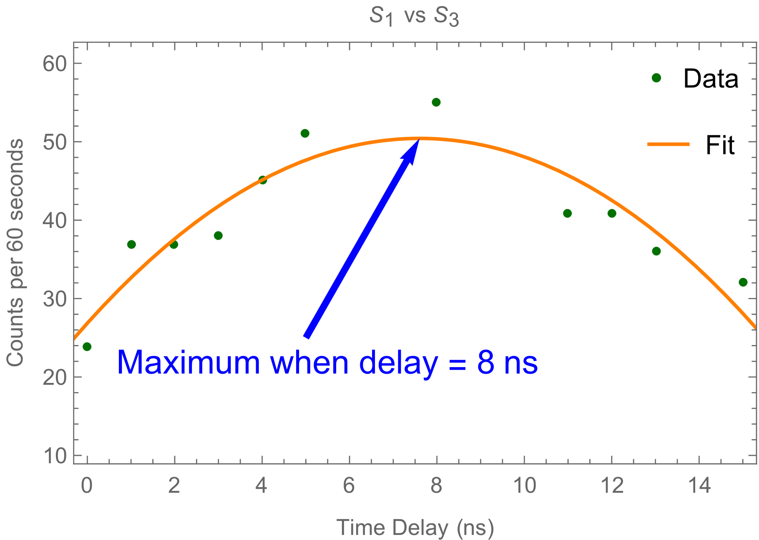

**III. Calibration of Maestro Software**

In our experiment, a computer running Maestro software served as our PHA and recorded our data. By default, Maestro will provide a histogram of energies vs. counts where the energies are linearly proportional to the time between the muon capture and muon decay signals. To determine the relationship between Maestro’s recorded energies and our muon’s decay times, we repeatedly sent two identical signals into the TAC, with the second signal being delayed by 2 . After one minute of run time, nearly all the counts recorded by Maestro were in the 840 keV bin. We then determined that each micro second corresponded to a 420 keV jump. Similarly, each keV bin was about 1/420 wide, or 23.8 ns. The data outputted by Maestro was multiplied by 1/420 which transformed our histogram of energies into a histogram of times.

**IV. Computer Analysis Tools**

The code repository for this project can be found at <http://www.github.com/syntaxvoid/Muon-Lifetime>. It contains all the relevant data, code, documentation, and resources and is well documented.